**Question 1**

Given the following diagram design the Animal, Cat and Dog class:

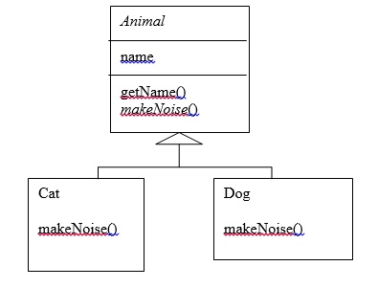

**Question 2**

Create a class called Employee whose objects are records for an employee. This class will be a derived class of the class Person which you will have to copy into a file of your own and compile. An employee record has an employee's name (inherited from the class Person), an annual salary represented as a single value of type double, a year the employee started work as a single value of type int and a national insurance number, which is a value of type String.  
  
Your class should have a reasonable number of constructors and accessor methods, as well as an equals method. Write another class containing a main method to fully test your class definition.

**Question 3**

A class called Author is designed as follows:

* Three private member variables: name (String), email (String), and gender (char of either 'm' or 'f' - you might also use a boolean variable called isMale having value of true or false).
* A constructor to initialize the name, email and gender with the given values.  
  (There is no *default constructor*, as there is no default value for name, email and gender.)
* Public getters/setters: getName(), getEmail(), setEmail(), and getGender().  
  (There are no setters for name and gender, as these properties are not designed to be changed.)
* A toString() method that returns "*name* (*gender*) at *email*", e.g., "Tan Ah Teck (m) at ahTeck@somewhere.com".

Design a Book class. Assume that a book is written by one (and exactly one) author. The Book class contains the following members:

* Four private member variables: name (String), author (an *instance* of the Author class we have just created, assuming that each book has exactly one author), price (double), and qty (int).
* The public getters and setters: getName(), getAuthor(), getPrice(), setPrice(), getQty(), setQty().
* A toString() that returns "'book-name' by author-name (gender) at email". You could reuse the Author's toString() method, which returns "author-name (gender) at email".

**Question 4** - **Painting Shapes**

In this exercise you will develop a class hierarchy of shapes and write a program that computes the amount of paint needed to paint different objects. The hierarchy will consist of a parent class Shape with three derived classes - Sphere, Rectangle, and Cylinder. For the purposes of this exercise, the only attribute a shape will have is a name and the method of interest will be one that computes the area of the shape (surface area in the case of three-dimensional shapes). Do the following.

* 1. Write an abstract class Shape with the following properties:

An instance variable shapeName of type String

An abstract method area() ­

A toString method that returns the name of the shape

* 1. The file Sphere.java contains a class for a sphere which is a descendant of Shape. A sphere has a radius and its area (surface area) is given by the formula 4\*PI\*radius^2. Define similar classes for a rectangle and a cylinder. Both the Rectangle class and the Cylinder class are descendants of the Shape class. A rectangle is defined by its length and width and its area is length times width. A cylinder is defined by a radius and height and its area (surface area) is PI\*radius^2\*height. Define the toString method in a way similar to that for the Sphere class.
  2. The file Paint.java contains a class for a type of paint (which has a "coverage" and a method to compute the amount of paint needed to paint a shape). Correct the return statement in the amount method so the correct amount will be returned. Use the fact that the amount of paint needed is the area of the shape divided by the coverage for the paint. (NOTE: Leave the print statement - it is there for illustration purposes, so you can see the method operating on different types of Shape objects.)
  3. The file PaintThings.java contains a program that computes the amount of paint needed to paint various shapes. A paint object has been instantiated. Add the following to complete the program:

Instantiate the three shape objects: deck to be a 20 by 35 foot rectangle, bigBall to be a sphere of radius 15, and tank to be a cylinder of radius 10 and height 30. Make the appropriate method calls to assign the correct values to the three amount variables.

­

Run the program and test it. You should see polymorphism in action as the amount method computes the amount of paint for various shapes.

**Question 5**

Write the superclass Shape and its subclasses Circle, Rectangle and Square, as shown in the diagram.

## ExerciseOOP_ShapeAbstract.png

In this exercise, Shape shall be defined as an abstract class, which contains:

* Two protected instance variables color(String) and filled(boolean). The protected variables can be accessed by its subclasses and classes. They are denoted with a '#' sign in the diagram.
* Getter and setter for all the instance variables, and toString().
* Two abstract methods getArea() and getPerimeter() (shown in italics in the diagram).

The subclasses Circle and Rectangle shall *override* the abstract methods getArea() and getPerimeter() and provide the proper implementation. They also *override* the toString().

**Question 6**

Suppose that we have a set of objects with some common behaviors: they could move up, down, left or right. The exact behaviors (such as how to move and how far to move) depend on the objects themselves. One common way to model these common behaviors is to define an interface called Movable, with abstract methods moveUp(), moveDown(), moveLeft() and moveRight(). The classes that implement the Movable interface will provide actual implementation to these abstract methods.

For the MovablePoint class, declare the instance variable x, y, xSpeed and ySpeed. For the MovableCircle class, use a MovablePoint to represent its center (which contains four variable x, y, xSpeed and ySpeed). In other words, the MovableCircle composes a MovablePoint, and its radius.

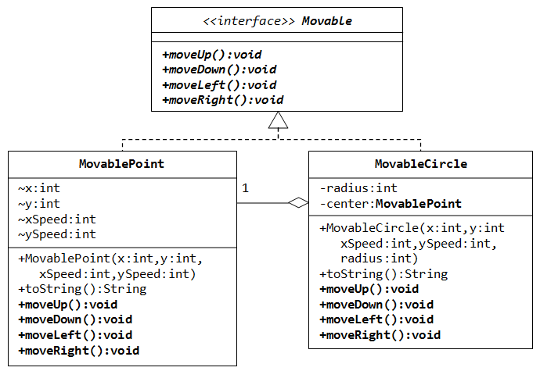

**Question 7**

1. Write the interface called GeometricObject, which declares two abstract methods: getParameter() and getArea().
2. Write the implementation class Circle, with a protected variable radius, which implements the interface GeometricObject.
3. Write a test program called TestCircle to test the methods defined in Circle.
4. The class ResizableCircle is defined as a subclass of the class Circle, which also implements an interface called Resizable, as shown in diagram. The interface Resizable declares an abstract method resize(), which modifies the dimension (such as radius) by the given percentage. Write the interface Resizable and the class ResizableCircle.
5. Write a test program called TestResizableCircle to test the methods defined in ResizableCircle.

